Anexa 1
la Nota privind crearea rețelei de resurse educaționale deschise

Fișă de identificare RED

Nume/prenume autor: KOVÁCS-GORBOI KATALIN- MELINDA
Denumirea resursei educaționale propuse: Celebrating Thanksgiving Day
Tema/scurta descriere: acest plan de lecție propune prezentarea, într-un mod interactiv, a unui segment al culturii anglo-saxone pentru elevii de liceu. Materialul include planul de lecție și materialele folosite. Sunt incluse activități individuale, în perechi, grupe, elevii având ocazia să-și exerseze toate capacitățile lingvistice.
Scopul materialului propus:
- didactic (de utilizat la clasă/cu elevii
- pentru elev (de utilizat de către elevi)
- de documentare pentru cadre didactice
- altele ………………………………….
Nivel de învățământ /clasa: liceu
Aria curriculară/disciplina: LIMBA ENGLEZĂ
Material extracurricular:-
Competențe vizate: - să identifice ideile principale dintr-o prezentare( text audiat/ citit)
- să coreleze mai multe tipuri de informaţii pentru a rezolva o sarcină de lucru, .
- să prezinte oral descrieri şi opinii legate de tema lecției
- să redacteze un text funcțional ( o scrisoare) respectând convențiile specifice
Lesson plan

School: Petru Maior Tehnological High School, Reghin
Date: 28th November 2019
Name: Kovács- Gorboi K. Melinda
Class: 11th A Level: Advanced Nr. of students: 20 Time: 50’ from 1 p.m. to 2 p.m.
Lesson: Celebrating Thanksgiving Day
Skills involved: all skills, more focus on speaking
Source: https://www.smithsonianmag.com/history/what-was-on-the-menu-at-the-first-thanksgiving, http://www.getty.edu/art/collection/objects/240991/richard-c-miller-thanksgiving-table-american-1941/, https://www.loc.gov/teachers/classroommaterials/presentationsandactivities/ presentations/thanksgiving/timeline/1941.html
Class organization: T-S, IW, PW, GW
Objectives:1. to introduce students to the topic
2. to familiarize students with the origins of celebrating Thanksgiving Day
3. to analyze different aspects of this celebration along the history
4. to apply certain aspects of this holiday in the classroom
Competencies to be practiced:- expressing opinions
-working in pairs and groups
- making a presentation/role play
- listening for key information
- writing a persuasive letter
-speaking about pictures
- writing thank you notes
Materials: power point presentation
paper slips with questions
worksheet
sets of pictures
questions used for talking about pictures
a large cardboard pumpkin for displaying the thank you notes
stickers
food
Contents:
Ice breaker activity: the day before the lesson, the students receive an invitation to a Thanksgiving Day Feast. At the beginning of the lesson the students enter the classroom and place on the table the items they brought for the lesson. Then they will search for their names on the chairs arranged in a circle and sit down. Timing: 3’

Objective 1: - context: introducing the topic - Warm up
-activities: there are 20 cards, stuck on colourful papers in colours suitable for the topic, each with a question on them, put face down on the table in front of the students. They will pick a card, mingle, and discuss it with another student, then exchange the card, receive a different question and move on to another student. They speak with 3-4 different classmates. Timing: 4’

Objective 2: - context: historical background – the beginnings
-activities:- the students together with the teacher will travel through 400 years to imagine how people celebrated on this day.
- two students have prepared a brief presentation and will show it to the class, with the goal of pointing out the most relevant parts of the origin of Thanksgiving. Students will put down on their worksheets 3 ideas they consider to be relevant – pair work.
-after that, the class will speak about a painting projected on the board that depicts the first Thanksgiving dinner. They will describe the picture, and then imagine what the people were doing before and after that scene. They have a word bank at their disposal. Timing: 10’

Objective 3: - context: celebration in the following centuries
- activities: - students work in 4 groups. Each group receives a set of pictures and a set of questions. As a first task they will match the pictures with the date they were created on and their topic. Following this, each student chooses 3 cards and speaks about one or more pictures. Whole class check up follows and then the groups present a few of their ideas. Timing: 10’
- continuing our travel, the students are at the end of the 20th century and are going to write a letter to a farmer to persuade them not to have turkey for Thanksgiving dinner. The groups present their letters to the class and the other groups choose which argument was the most convincing. Timing 8’

- context: present day Thanksgiving
-activities: role play: - a group of students have prepared a TV news programme about Thanksgiving Day festivities in 2019. They present it to the class. Timing 4’

Objective 4: - context: Thanksgiving among us
-activities: - students pick a slip of paper with a classmate’s name on it. They will have to write something to the other person they are grateful for. These thank you notes will be displayed on a cardboard pumpkin so the students can read and re-read each other’s notes. Timing 5’
- after feedback, students receive a sticker and then move their chairs and sit down around the Thanksgiving table and taste the food brought by them.

MATERIALS:
Worksheet
CELEBRATING THANKSGIVING DAY
Word bank
gravy = a brown sauce roast turkey cranberry sauce
pumpkin pie corn pilgrims = a person who travels for religious reasons
Native Americans = Indians grateful=thankful prayer
to pardon = to forgive, to save harvest = the act of cutting and gathering the crops on the farm

- Write down 3 ideas that you remember about the history of Thanksgiving.
.....................................................................................................................................................
.....................................................................................................................................................
......................................................................................................................................................
- Match the pictures with the year and what it shows.

What can we see | Year | Picture no.
Thanksgiving Table | 1942
Thanksgiving during the Civil War | 1941
Family praying before carving the turkey | 1861
Football match played on Thanksgiving Day | 1917
Thanksgiving Day dinner in the army | 2016
The president of the USA pardoning a turkey | 2013
Family watching NFL match after dinner | 1903

- Letter to a farmer written at the end of the 20th century
Dear farmer,
...........................................................................................................................................................................................................................................................................................................................................................................................................................................................................................................................................................................................................................................................................................................................................................................................................................................................................................................................................................................................................................................................................................................................................................................
Questions for warm up:
1.What does being thankful mean?
2.I am most thankful for ...
3.A person I am grateful for because they inspire me ......
4.Something about myself I am thankful for is...
5.What opportunities are you thankful for?

Picture used for whole class description:
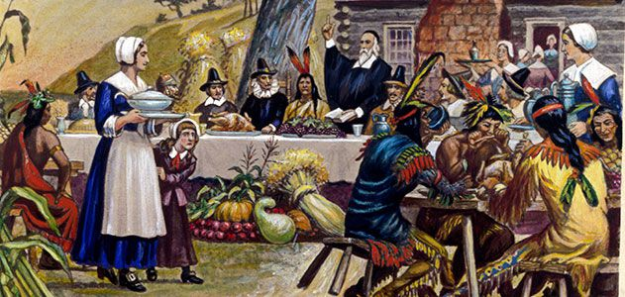
1621
Questions used for speaking about pictures:

- Why did you choose this picture?
- What are 3 words that describe this person?
- What do we know about this person from their facial expression?
- What do we know about this person from what they are wearing?
- What time period & culture do they come from? How do you know?
- What is this person’s daily life like - job, food, relationships, etc.?
- Why was this portrait made?
- What would you like to ask this person?
- What is this person’s biggest secret?
- What advice do you want to give this person?
- What are three words that describe this picture?
- Why was this picture made?
- What did the artist want to show?
- How would you change this picture?
- Would you want this picture in your home? Why? Why not?
- Where is this place? How do you know?
- What are the sights, smells, tastes, sounds, textures there?
- What do people do in this place?

Pictures:
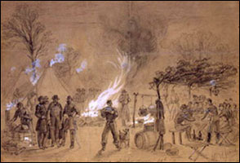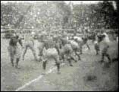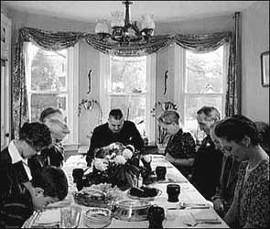
1861 1903 1942
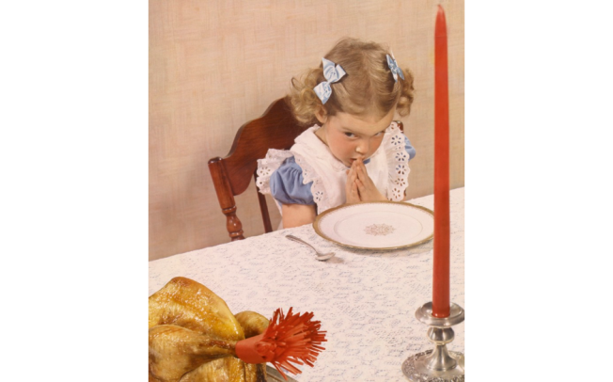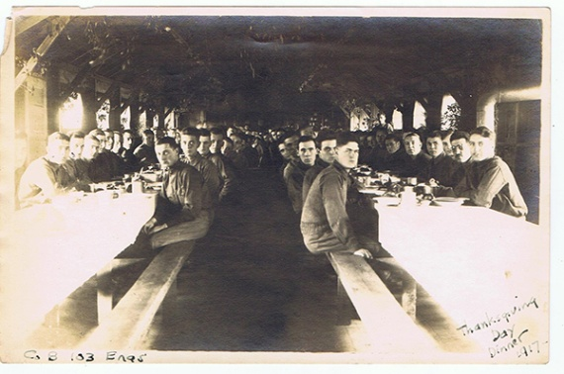
1941 1917
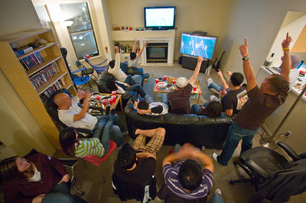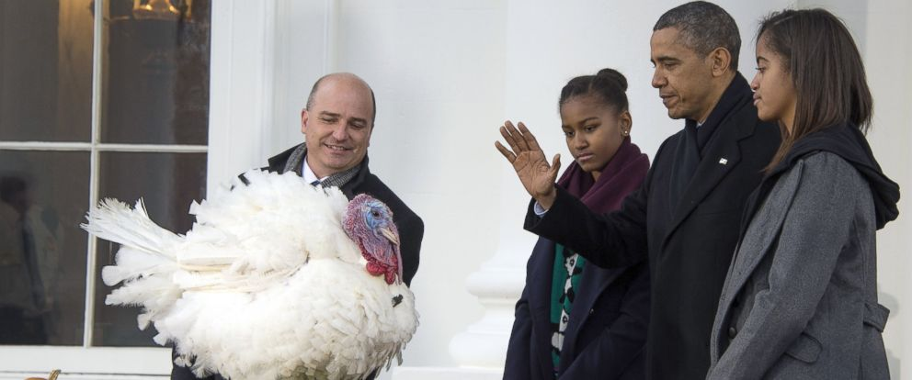
2016 2013

Stickers:
